NTISEPTIC HAND CLEANER
Antiseptic Hand Soap

$17.27/ gallon

Formulated with a pleasant fragrance and moisturizing agents, it is designed to provide mild cleansing action suitable for frequent use. It is a mild cleanser with broad-spectrum antimicrobial action leaving hands feeling clean with no residue remaining.

Spa Body Shampoo

$10.00/gallon
$40.00/case

Luxurious, ultra-cosmetic ingredients provide thick, rich lather for hair and body cleansing. With a pleasant bouquet fragrance, it contains conditioning ingredients and is fortified with aloe vera and lanolin for frequent showering and shampooing without dryness.

SD-20: All Purpose Degreaser

$5.21/can

Designed to foam away dirt, grease and fingerprints from washable surfaces. The clinging foam, no rinse formula allows concentration of the product on stubborn spots and aids in spot cleaning.

Home Cleaning Kit!

$13.48

Xcelente: multi-purpose, hard surface cleaner with a fresh, clean fragrance of lavender
NABC (Non-Acid Bathroom Cleaner): cleans, disinfects, and deodorizes toilet bowls, urinals and other restroom surfaces
Fast & Easy: cuts through grease, soot, and other hard to remove soils by simply spraying and wiping dry

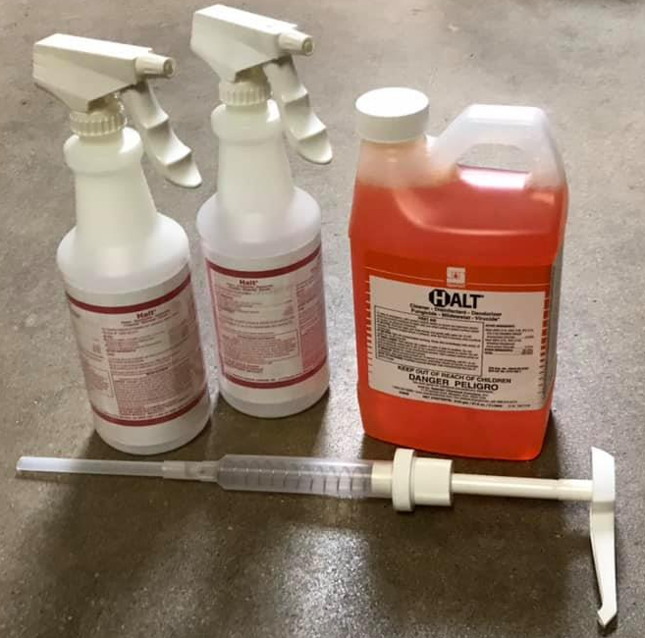
Halt Disinfecting Kit!

$27.32

Makes 68-quart bottles of spray disinfectant for cleaning and disinfecting hard surfaces! Package includes a 2-liter bottle of concentrated disinfectant, 2 labeled empty spray bottles, and a one-ounce pump.

- Screw one-ounce pump into 2-liter Halt disinfectant bottle
- Put one pump of Halt into each empty bottle and fill with water
- Spray onto hard surfaces and wipe off

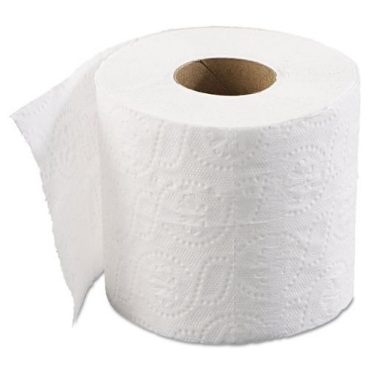
2-Ply Toilet Paper

$44.89/ case of 96 rolls

Our standard bath tissue is embossed to provide a soft and comfortable feel. Reliable 2-ply performance at a low cost!

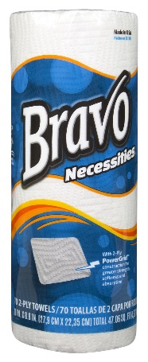
Bravo Necessities Paper Towel

$26.95/ case of 30 rolls

Stay on top of life’s little necessities with Bravo Necessities® paper towels! These economical paper towels are the perfect workhorse for day to day household chores, spills, and messes. Unique 2-Ply PowerGrid™ design offers greater absorbency, softness, strength and reliability!

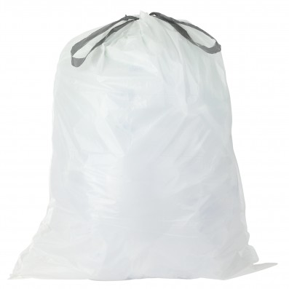

Kitchen Garbage Bags

$32.99

11-12-gallon trash bag designed to fit a standard kitchen garbage can! Case of 300 bags!

