It’s Stripping Season!

Find out how to do it right at our
Hard Floor Care Seminar!

Our training is done “Live” with cleaning industry tools in normal cleaning use.

You will learn:
- Importance of analyzing a floor and baseboards before you start the job (ie. Stripped, scrub & recoat, or total restoration):
- Testing to determine the appropriate stripper
- Determining the best floor finish for the job based on the maintenance program used by the facility.
- Importance of weather conditions and climate controlled rooms
- Importance of dry times
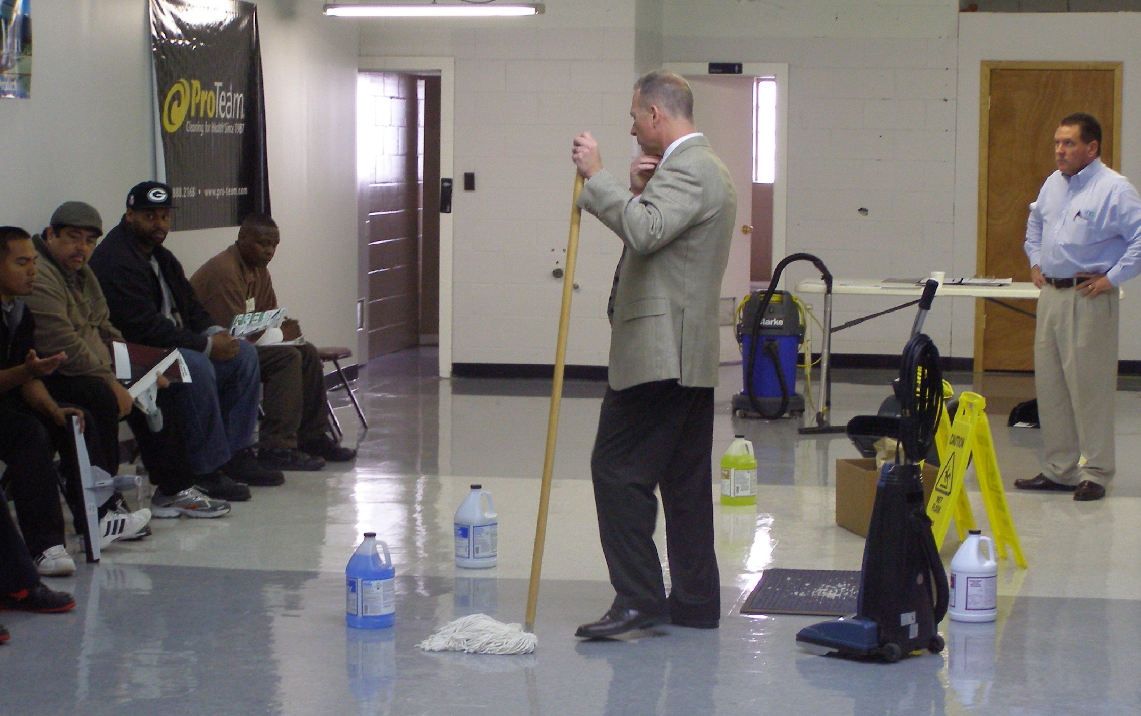
- Climate control buildings
- Hands-on stripping of a floor:
- Proper pad usage
- Power equipment and manual tools
- Importance of neutralizing and analyzing floor
- PH testing floor before laying finish
- Hands-on application of floor finish:
- Right applicator for the job

Date: Wednesday May 4th, 2016
Time: 9:00am - 11:30am Hard Floor Care
11:30 - 12:00pm Equipment Maintenance

Location: Right Choice Janitorial Supply, LLC
Seating is limited!
Call or email today to ensure your reservation!

Training Room

6464 N. Teutonia Avenue

Milwaukee, WI 53209

Investment: $29.95

Sign-Up: Call 414-716-2000 or email craigjr@rightchoicejanitorial.com

Remember, 97% of the cost of your project is LABOR.
Training will help reduce labor costs!

Helpful Tips on Cleaning!
Square Footage
- Accurately measure square footage of the project and ensure you have enough product on hand.

Staging Mat
- Using a staging mat will eliminate excess clean-up.

Splash Collar
- Using a splash collar will eliminate wall splatter

Floor Dryers
- Always use floor dryers to speed up the carpet drying process to eliminate chance of mold build-up

Drying Times
- Know whether the heat or air conditioning is turned off in the building. This will considerably effect drying times.

Outside Entrance
- 90% of all soil is tracked in from the building entrance. Use entrance matting year round and clean outside front door to minimize tracking.
2016 Training Class Schedule
Class Date Time

Marketing, Bidding, Estimating and Proposals March 9th 8:00am – 12:00pm

Restroom & Office Cleaning & Globalized April 13th 1:30pm – 3:30pm
Harmonized System

Hands-on Floor Care & Hazard Update May 4th 9:00am – 12:00am

Hands-on Carpet Care May 11st 10:00am – 12:00pm

Customer Appreciation Day! August 11th 11:00am – 2:00pm

Essential Equipment Maintenance September 21st 1:00pm – 3:00pm

Cost of Winter Cleaning October 19th 1:00pm – 3:00pm

Sales and Marketing of Your Business November 9th 8:00am – 12:00pm

Did you know that 97% of the cost of a cleaning is labor?
Research shows companies who train their employees have reported
6 times better
employee retention!

