It’s Stripping Season!

Find out how to do it right at our
Hard Floor Care Seminar!

Our training is done “Live” with cleaning industry tools in normal cleaning use.

You will learn:
- Importance of analyzing a floor and baseboards before you start the job (ie. Stripped, scrub & recoat, or total restoration):
- Testing to determine the appropriate stripper
- Determining the best floor finish for the job based on the maintenance program used by the facility.
- Importance of weather conditions and climate controlled rooms
- Importance of dry times
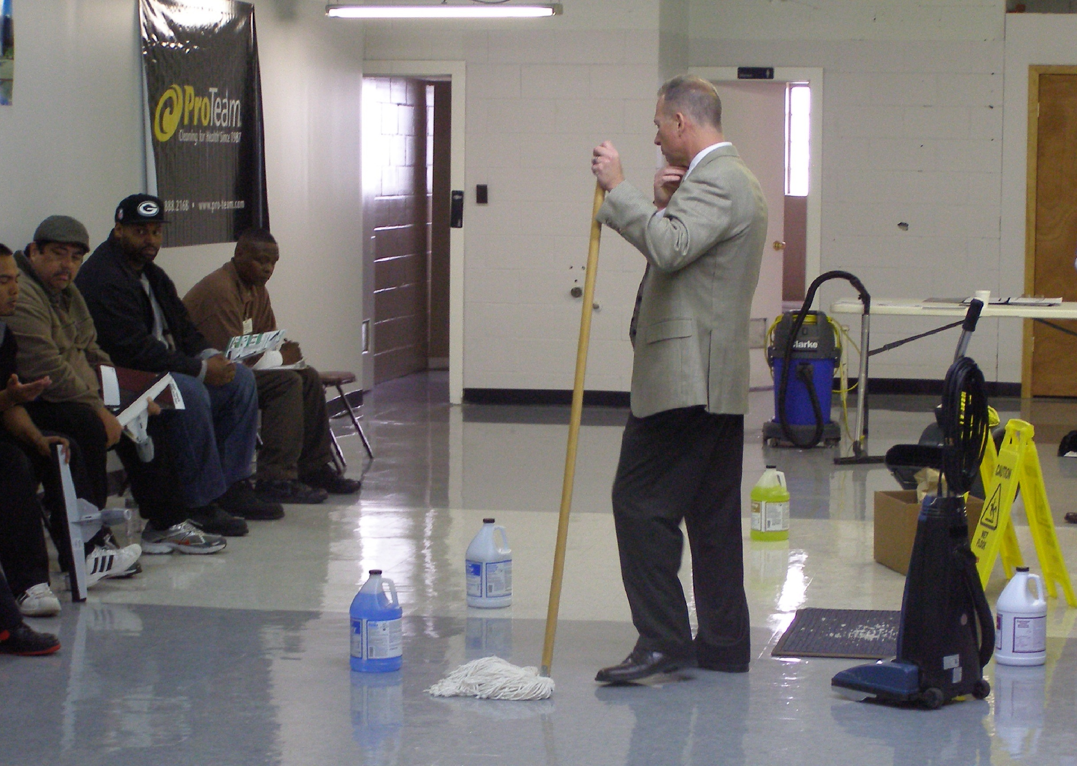
- Climate control buildings
- Hands-on stripping of a floor:
- Proper pad usage
- Power equipment and manual tools
- Importance of neutralizing and analyzing floor
- PH testing floor before laying finish
- Hands-on application of floor finish:
- Right applicator for the job

Date: Wednesday May 16th , 2018
Time: 9:00am - 11:30am Hard Floor Care
Today Only!
Special Deals on Floor Care Equipment!
11:30 - 12:00pm Equipment Maintenance

Location: Right Choice Janitorial Supply, LLC

Training Room

6464 N. Teutonia Avenue

Milwaukee, WI 53209

Investment: $39.95

Sign-Up: Call 414-716-2000 or email craigjr@rightchoicejanitorial.com

Remember, 97% of the cost of your project is LABOR.
Training will help reduce labor costs!

