It’s the seminar you have been waiting for!
Bidding and Estimating for Janitorial Contracts
Do you understand the number of hours it truly takes to clean and maintain your facility?
Do you want an
“F”
cleaning performance?
Or an
“A”
cleaning performance?
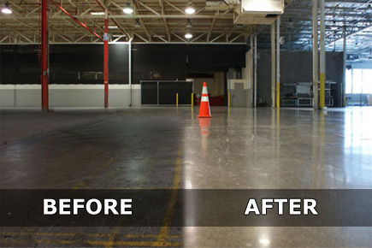

You will learn:
- How to calculate cleanable square footage vs. actual square footage
- How many square feet an hour it will take to clean
- How many square feet an hour you should be cleaning (industry static will be discussed)
- How to determine task frequencies
- How to upsell carpet and floor care programs

The seminar will include a free Cleaning Times Calculator giving you time studies on ISSA Cleaning standards.

Bidding, Estimating, and Proposals for Janitorial Contracts!
Call us today at
414-716-2000
or email us at craigjr@rightchoicejanitorial.com to register
Presenter: Bob Merkt, Certified IICRC Trainer
Date: Wednesday April 25th, 2018
Time: 8:00am – noon
Location: Right Choice Janitorial Supply Training Center
6464 N. Teutonia Avenue, Milwaukee
Investment: $89.95 per person

Right Choice Janitorial Supply, LLC
2017 On-Site Training Class Schedule

Topic Date Time Presenter Investment

Bidding & Estimating 4/25/18 8:00am – 12:00pm Robert Merkt $89.95

Office/Restroom Cleaning TBA 1:30pm – 3:30pm Jim Traudt $49.95

Hands-On Hard Floor Care 5/16/18 9:00am – 12:00pm Jim Traudt $39.95

Hands-On Carpet Care 6/13/18 10:00am – 12:00pm Craig Wallace $39.95

Customer Appreciation Day 8/9/18 11:00am – 2:00pm

Essential Equipment Maint. TBA 1:00pm – 3:00pm John Berte $39.95

Cost of Winter Cleaning TBA 1:00pm – 3:00pm Tom Parris $39.95

Essential Equipment Maint. TBA 1:00pm – 3:00pm John Berte $39.95

Cost of Winter Cleaning TBA 1:00pm – 3:00pm Tom Parris $39.95

Check our website www.rightchoicejanitorialsupply.com for more information.

