Do you understand the hours it truly takes to clean and maintain your facility?
If not, your building will not be properly maintained.
Do you want an
“F”
cleaning performance?
Or an
“A”
cleaning performance?
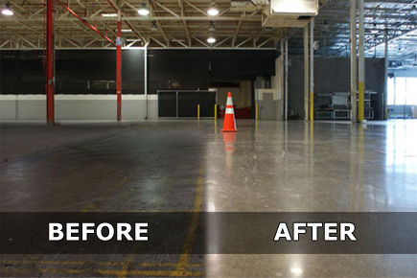

Are you in charge of the cleaning and maintenance of your facility?
Are you a contract cleaner?

You must attend this seminar to learn:
- How to calculate cleanable square footage vs. actual square footage
- How many square feet an hour it will take to clean
- How many square feet an hour you should be cleaning (industry static will be discussed)
- How to determine task frequencies
- How to formulate the proposal

The seminar will include a free Cleaning Times Calculator giving you time studies on ISSA Cleaning standards.

Bidding, Estimating, and Proposals for Janitorial Contracts!
Call us today at
414-716-2000
or email us at craigjr@rightchoicejanitorial.com to register
Presenter: Bob Merkt, Certified IICRC Trainer
Date: Wednesday March 9th, 2016
Time: 8:00am – noon
Location: Right Choice Janitorial Supply Training Center
6464 N. Teutonia Avenue, Milwaukee
Investment: $75.00 per person
With proper training, these are the results you get:*

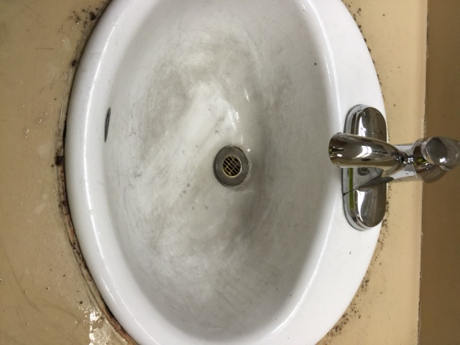
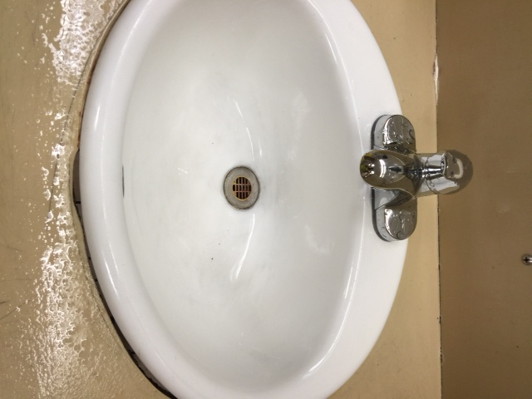
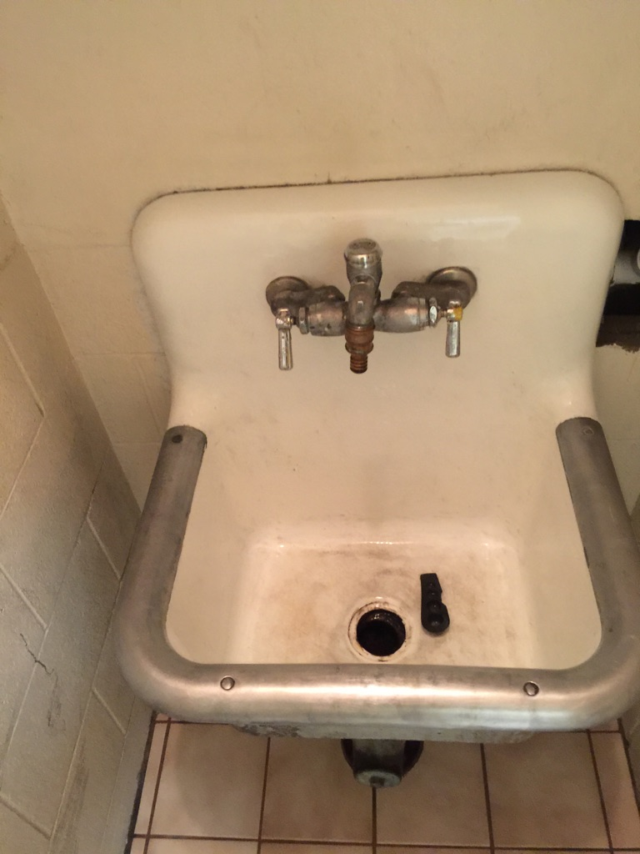
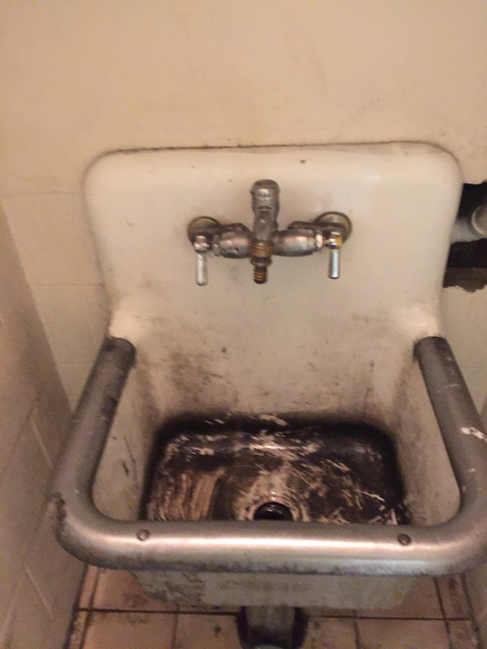

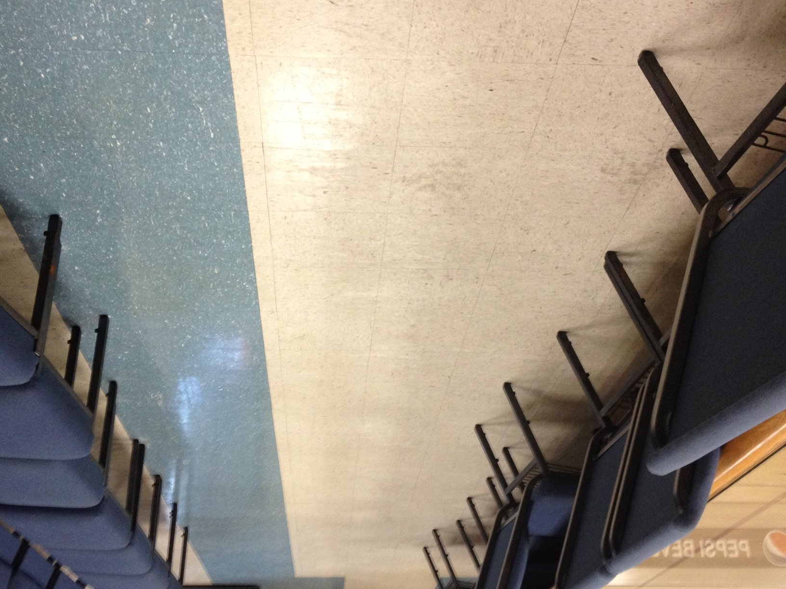
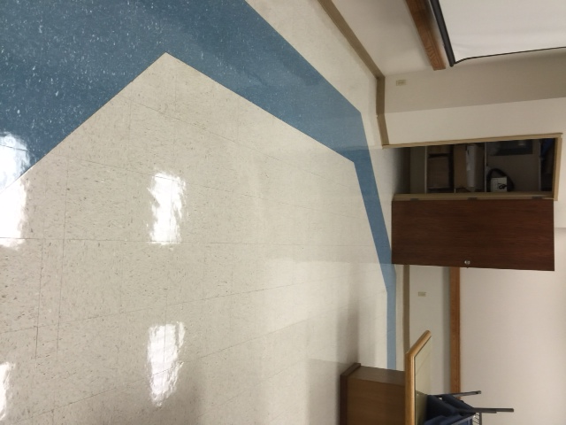
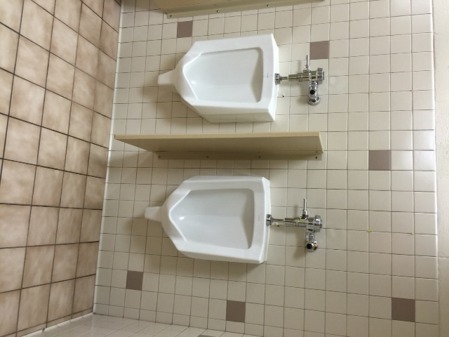
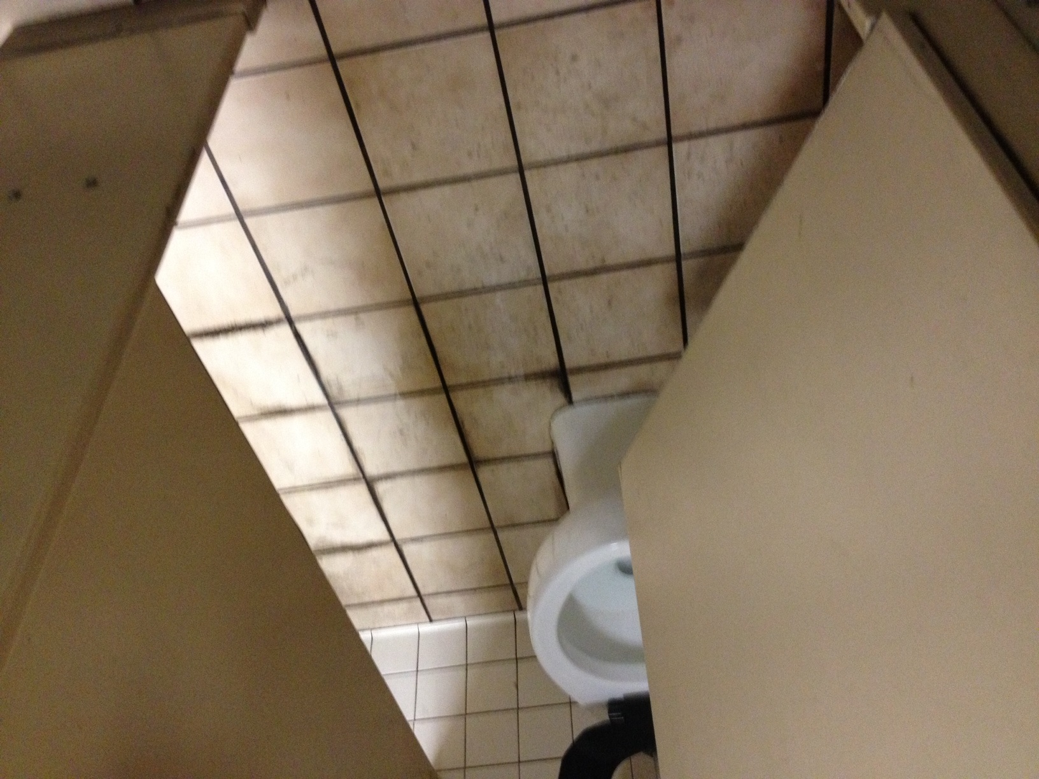

*Photos curtesy of Two Girls One Bucket from actual projects performed by their company.

