Would you like to know the
Newest Technology in Carpet Cleaning
and learn how to
Best Sell Your Services?
The Experts are in!
Attend the
Hands-On Carpet Care
Seminar
Presenters
Doug Berjer, CFR Sales Manager and Craig Wallace, CFR Regional Manager

Location: Right Choice Janitorial Supply, LLC Training Room
6464 N. Teutonia Avenue
Milwaukee, WI 53209
Date: May 10, 2017
Time: 10:00am – 12:00pm
Investment: $29.95
Registration: Call 414-716-2000 or email us at craigjr@rightchoicejanitorial.com
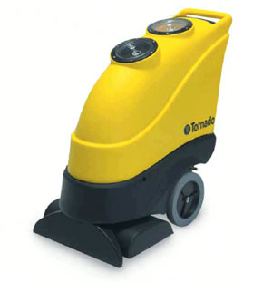
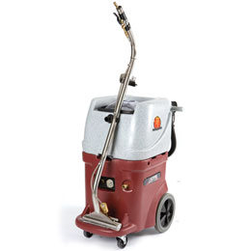
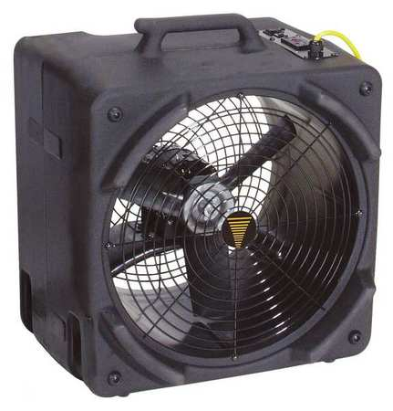
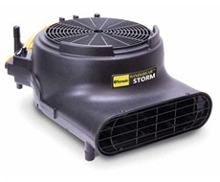

Tornado Windstorm Air Mover
$199

Tornado Marathon 1200 Automatic walk behind Carpet Scrubber – Demo $2,375
WindShear Side Draft
$349.50
Pro-Series Continuous Flow Recycling Extractor

Today Only!
Special deals on carpet equipment!
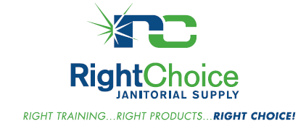

Special Deal on Training!
Participate in both the Hard Floor Training Class AND Carpet Care Training Class for one low price of $39.95!
Did you know that 97% of the cost of a cleaning is labor?
Research shows companies who train their employees have reported
6 times better
employee retention!

