Would you like to know the
Newest Technology in Carpet Cleaning
and learn how to
Best Sell Your Services?
The Experts are in!
Attend the
Hands-On Carpet Care
Seminar
Presenters
Doug Berjer, CFR Sales Manager and Craig Wallace, CFR Regional Manager

Location: Right Choice Janitorial Supply, LLC Training Room
6464 N. Teutonia Avenue
Milwaukee, WI 53209
Date: Wednesday June 13th, 2018
Time: 10:00am – 12:00pm
Investment: $39.95
Registration: Call 414-716-2000 or email us at craigjr@rightchoicejanitorial.com
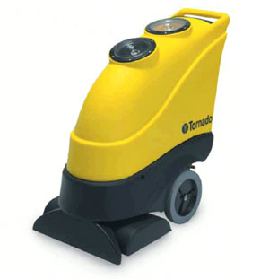
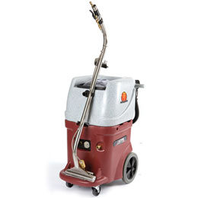
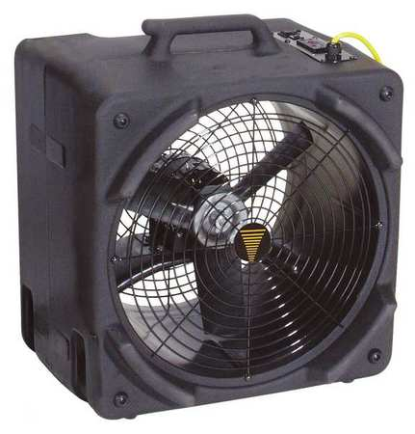
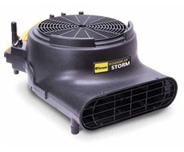

Tornado Windstorm Air Mover
$199

Tornado Marathon 1200 Automatic walk behind Carpet Scrubber – Demo $2,375
WindShear Side Draft
$349.50
Pro-Series Continuous Flow Recycling Extractor

Today Only!
Special deals on carpet equipment!
