Would you like to know the
Newest Technology in Carpet Cleaning
and learn how to
Best Sell Your Services?
The Experts are in!
Attend the
Hands-On Carpet Care
Seminar
Presenters
Doug Berjer, CFR Sales Manager and Craig Wallace, CFR Regional Manager

Location: Right Choice Janitorial Supply, LLC Training Room
6464 N. Teutonia Avenue
Milwaukee, WI 53209
Date: May 11, 2016
Time: 10:00am – 12:00pm
Investment: $29.95
Registration: Call 414-716-2000 or email us at craigjr@rightchoicejanitorial.com
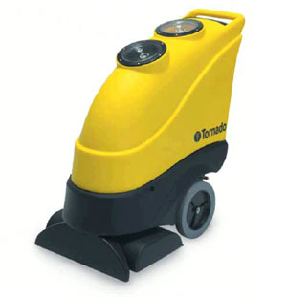
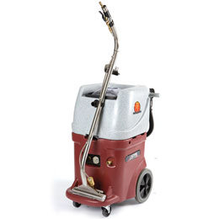
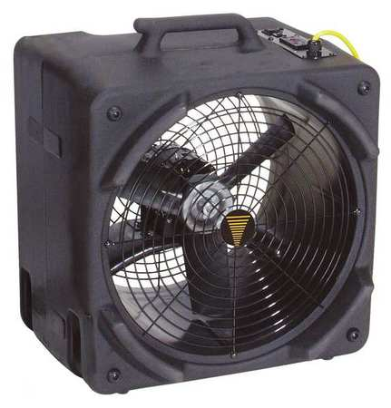
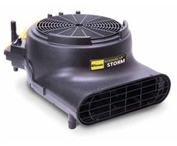

Tornado Windstorm Air Mover
$199

Tornado Marathon 1200 Automatic walk behind Carpet Scrubber – Demo $2,375
WindShear Side Draft
$349.50
Pro-Series Continuous Flow Recycling Extractor

Today Only!
Special deals on carpet equipment!

Helpful Tips on Spring Cleaning!
Square Footage
- Accurately measure square footage of the project and ensure you have enough product on hand.

Staging Mat
- Using a staging mat will eliminate excess clean-up.

Splash Collar
- Using a splash collar will eliminate wall splatter

Floor Dryers
- Always use floor dryers to speed up the carpet drying process to eliminate chance of mold build-up

Drying Times
- Know whether the heat or air conditioning is turned off in the building. This will considerably effect drying times.

Outside Entrance
- 90% of all soil is tracked in from the building entrance. Use entrance matting year round and clean outside front door to minimize tracking
Remaining 2016 Training Class Schedule
Class Date Time
Hands-on Floor Care & Hazard Update May 4st 9:00am – 12:00pm
Hands-on Carpet Care May 11th 10:00am – 12:00pm
Customer Appreciation Day! August 11th 11:00am – 2:00pm
Essential Equipment Maintenance September 21st 1:00pm – 3:00pm
Cost of Winter Cleaning October 19th 9:30am – 12:00pm
Sales and Marketing Your Business November 9th 8:00am – 12:00pm
Essential Equipment Maintenance December 7th 10:00am – 12:00pm or
3:00pm – 4:30pm

Did you know that 97% of the cost of a cleaning is labor?
Research shows companies who train their employees have reported
6 times better
employee retention!

