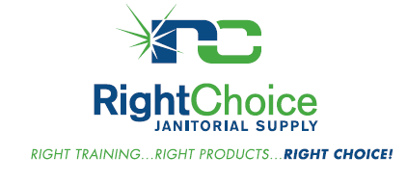

For the 4rd Annual
Customer Appreciation Day
Come on over for a famous
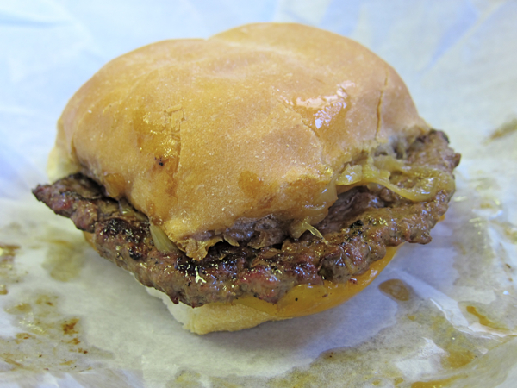
Miesfelds Steak Sandwich
and Sheboygan Hard Roll!

Featured Vendors
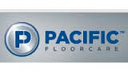
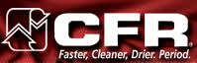

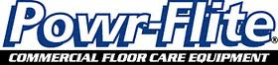

Door Prizes! However, you must RSVP by Friday August 7th to be entered into the drawings.

RSVP: craigjr@rightchoicejanitorial.com or 414-716-2000
Date: August 13th 2015
Time: 11:00am – 2:00pm
Location: Right Choice Janitorial Supply, LLC
6464 N. Teutonia Ave., Milwaukee

Have you given your rolls the weight test?

It’s a fact.

Vendors are reducing the size and length of toilet tissue and roll towels. This means you’re getting less product per case, ordering more frequently, and wasting labor with frequent roll changes. Oftentimes the case dimensions aren’t listed on the box. The only way to determine any discrepancy is by weight.
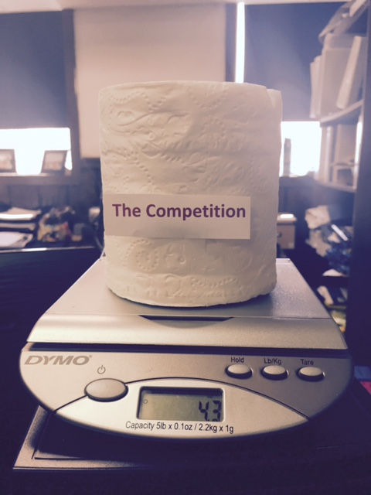
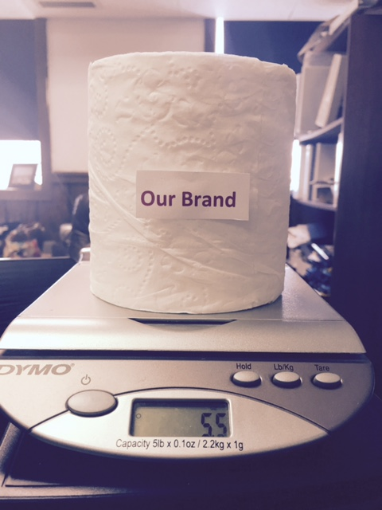

Call us today to take the weight test and get the best paper value for your money!

