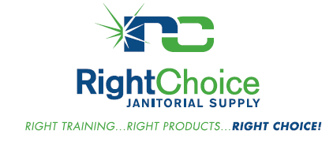
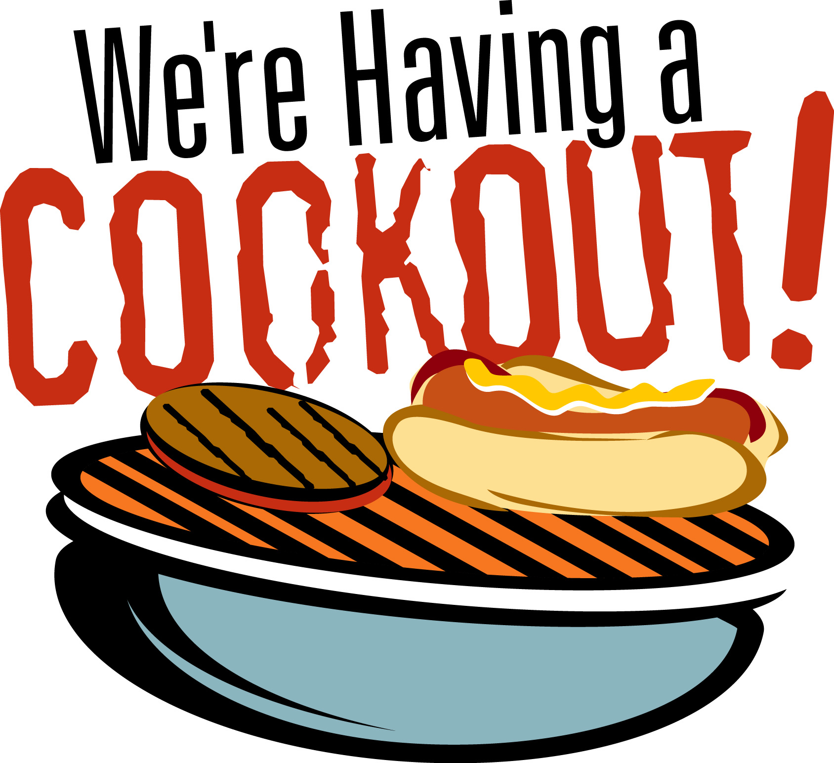

For the 5th Annual
Customer Appreciation Day
Come on over for a famous
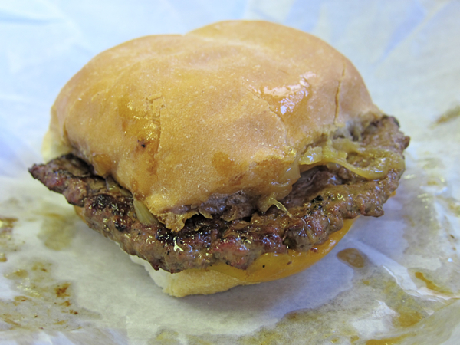
Miesfelds Steak Sandwich
and Sheboygan Hard Roll!

Featured Vendors
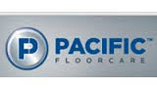
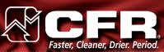
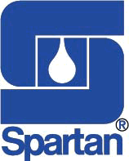

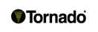
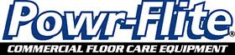

Door Prizes! However, you must RSVP by Friday August 5th to be entered into the drawings.

RSVP: craigjr@rightchoicejanitorial.com or 414-716-2000
Date: August 11th 2016
Time: 11:00am – 2:00pm
Location: Right Choice Janitorial Supply, LLC
6464 N. Teutonia Ave., Milwaukee

