Have you ever lost production rates
or
customers
due to
poor equipment maintenance?

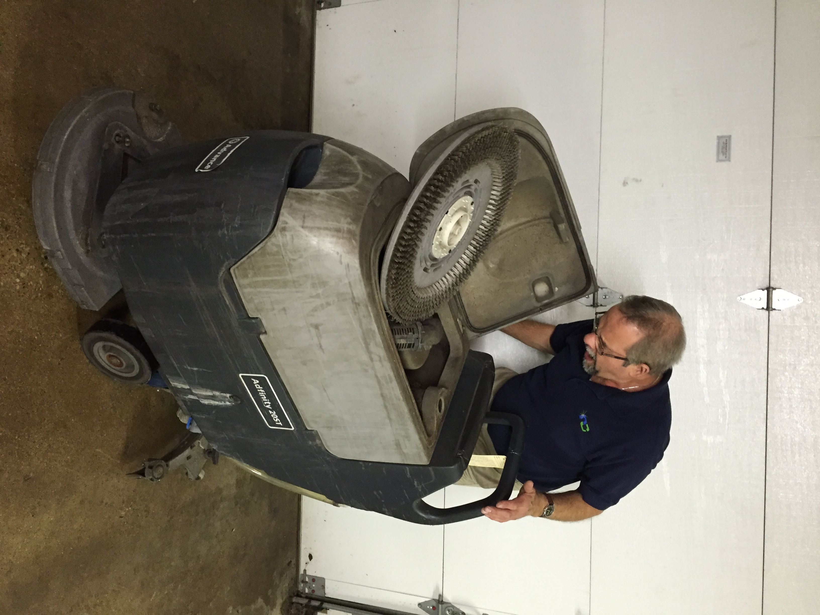

Attend one of these training sessions and let Right Choice Service Technicians train your employees on:
- Battery Maintenance
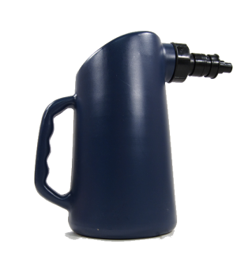
  - Battery filling device
- Squeegee Maintenance
- Importance of de-foamer usage
- On-site vacuum maintenance/trouble shooting
- Proper storage and cleaning of equipment

Remember, we are approaching the time of year when equipment maintenance is a high priority.

Date: September 21st, 2016
Time: 1:00pm – 3:00pm
Location: Right Choice Training Center
6464 N. Teutonia Avenue
Milwaukee
Investment: $49.95

Call us at 414-716-2000 or email us at craigjr@rchoicewi.com today to reserve your seat!

Automatic Scrubber Check-in/Out Form Checklist

 | Battery hydrometer & cell Test |  | Check recovery tank for dirt/leaks/clogs
 | Battery connections clean and tight |  | Check solution tank for dirt/leaks/clogs
 | Battery filled to proper level, tops/caps dry & clean |  | Check solution lines for dirt/leaks/clogs
 | Battery charger & connectors in working condition |  | Check solution filters for dirt/clogs
 | Control panel switches in proper working order |  | Solution valve shut off properly working
 | Electrical/lights are in proper working condition |  | Check squeegee blades for wear/dirt
 | Check Vac motor(s) for dirt/corrosion/noisy |  | Squeegee assembly properly adjusted
 | Vac motor(s) proper suction water lift at _____ |  | Squeegee picks up water properly
 | Check floor brush motor(s) for dirt/corrosion/noisy |  | Squeegee hoses free of leaks
 | Brush/pad have proper contact w/floor |  | Squeegee assemble raises/lowers properly
 | Brush/pad in proper working condition |  | Overall vacuum system working properly
 | Check brush splash guards for wear |  | Machine completely cleaned and “spit shined”
 | Drive train in proper working condition |  | Machine is properly tagged w/inventory ID
 | Chek/belts checked for wear/rust/corrosion |  | Test run machine from fill up to draining
 | Casters and wheels checked for wear/rust/corrosion
 | Casters and wheel lubricated and cleaned

Vacuum/Sweeper Check-in/Out Form Checklist
 | Cord free of cuts/cracks/shorts |  | Filters cleaned and/or replaced (intake,exhaust)
 | Cord plug in proper working condition w/ground |  | Paper/cloth bag cleaned and/or replaced
 | Switch works properly
 | Base Plate free of cracks
 | Motor in proper working order noisy/dusty/corroded |  | Batteries load tested
 | Front and rear wheels work properly |  | Batteries free of corrosion
 | Handle in proper working order |  | Battery cables in good condition
 | Belt is working properly and/or replaced
 | Brush roll spins free
 | Brush roll brushes are in good condition
 | Brush roll makes proper contact with floor |  | All moving parts lubricated
 | Brush adjustment works properly |  | Machine completely cleaned and “spit shined”
 | Vac attachments in proper working condition |  | Machine is properly tagged w/inventory ID
 | Hoses free of cracks, cuts, etc. |  | Completely test run machine
 | Wand free of cracks, cuts, etc.

Carpet Extractor Check-in/Out Form
Checklist
 | Control panel switches in proper working order |  | Spray tips clean/uncloggted
 | Gauges working properly |  | Spray tips have proper spray pattern
 | Electrical/lights are in proper working condition |  | Check solution tank for dirt/leaks/clogs
 | Check vac motor(s) for dirt/dorrosion/noisy |  | Check solution lines for dirt/leaks/clogs
 | Vac motor (s) proper suction water lift at _____ |  | Check solution filters for dirt/clogs
 | Vac shoe clear of clogs |  | Solution valve shut off properly working
 | Vac shoe properly adjusted |  | Casters & wheels checked for wear/rust/corrosion
 | Overall vacuum system working properly |  | Casters and wheels lubricated and cleaned
 | Check floor Brush motor(s) for dirt/corrosion/noisy |  | Machine completely cleaned and “spit shined”
 | Brush has proper contact w/floor |  | Machine is properly tagged w/inventory id
 | Brush in proper working condition |  | Test run machine from fill up to draining
 | Brush belt/chain n good condition
 | Check recovery tank for dirt/leaks/clogs

Low/High Speed Buffer Check-in/Out Form
Checklist
Cord free of cuts/cracks/shorts
Cord plug in proper working condition w/ground
Handle switches in proper working order
Safety switches in proper working order
Handle clamp in proper working order
Motor in proper working order noisy/dusty/corroded
Pad driver/brush adjusted properly
Pad driver holds pad on machine under load
Pad pressure adjustment in proper working condition
Solution tank in proper working condition
Machine completely cleaned and “spit shined”
Machine is properly tagged w/inventory ID
Completely test run machine

