What is the most common reason for losing a cleaning contract?
Restroom dissatisfaction!
Restrooms make up less than 5% of building size, have 40% of the total soil load in a building, and 50% of building complaints.

Learn about right towel, tissue, & hand soap dispensing systems!
This Restroom and Office Cleaning seminar will show you how.
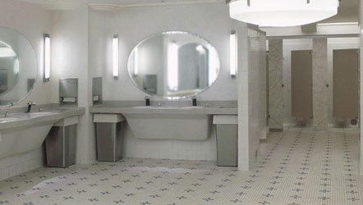
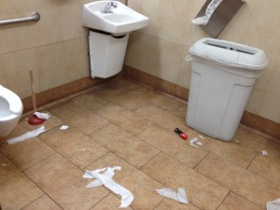
VS

Get an edge on the competition

- Restroom cleaning, office cleaning, and touch point cleaning
- Step-by-step information sheet on “How to Clean a Restroom” and “How to Clean an Office”
- Checklist of all items needed to clean a restroom and an office.
- Hands-on Training
- Requirements of the new Globally Harmonized System

Investment: $49.95

Presenters: Jim Traudt, VP Sales Right Choice Janitorial Supply, LLC
Tom Parris, Regional Sales Manager Spartan Chemical, Inc.
Location: Right Choice Janitorial Supply, LLC Training Room
6464 N Teutonia Avenue
Milwaukee, WI 53209
Seating is limited.
Email your reservation today!
Date: Wednesday April 12th, 2017
Time: 1:30pm -3:30pm
Email us at craigjr@rightchoicejanitorial.com to register for this seminar.
6464 N. Teutonia Avenue, Milwaukee, WI 53209, Ph. 414-716-2000, Fax 414-716-2020
Cleaning a Restroom Product Checklist
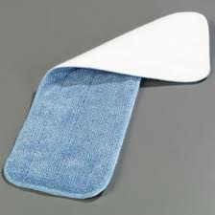
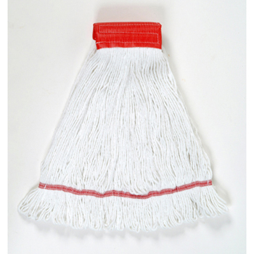
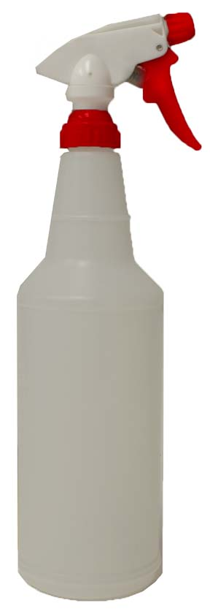
- Trigger Spray Bottles
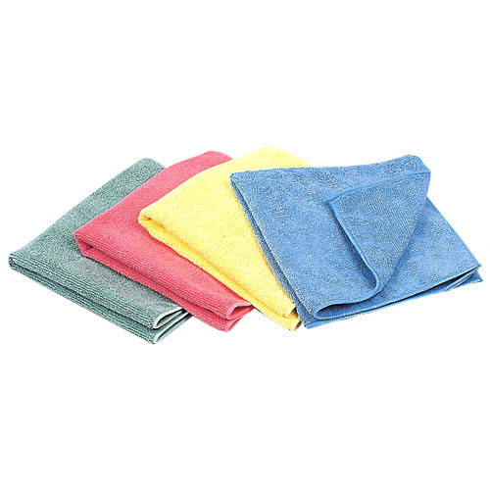
- Clean Cloths
- Flat Mop System
- Wet Mop and Handle
- 2 buckets with wringers OR 1 bucket and a pump up sprayer
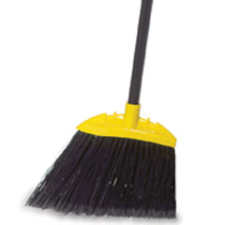
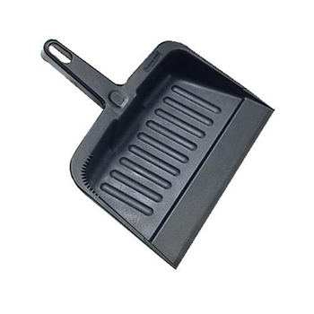
- Broom
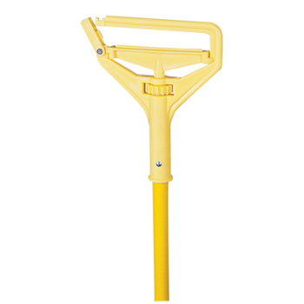
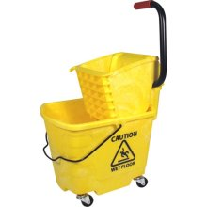
- Dust Pan
- Can Liners
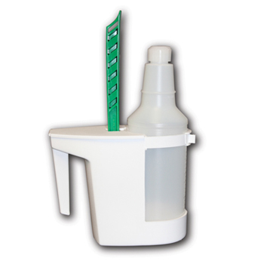
- Bowl Swab
- Bowl Swab Caddie
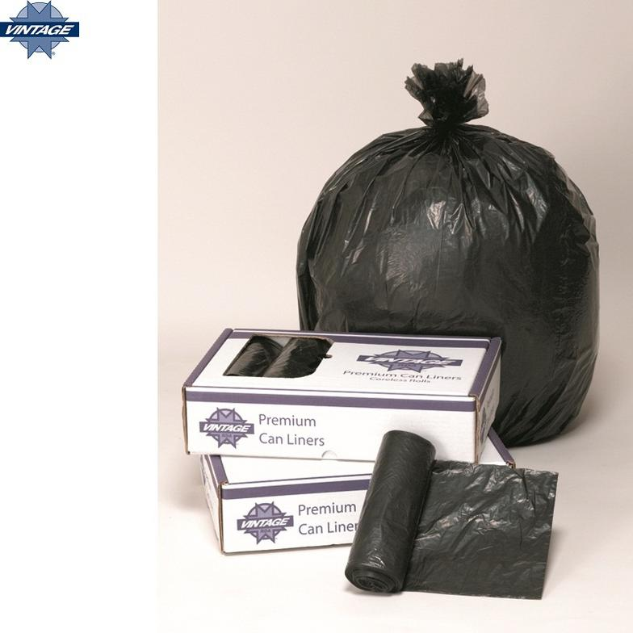
- Clean bucket for rinse water
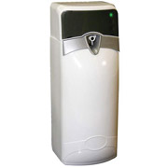
- “Wet Floor” signs
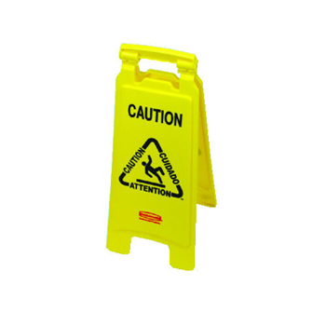
- Gloves
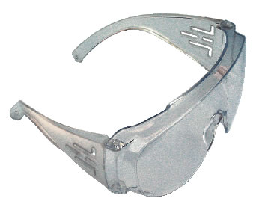
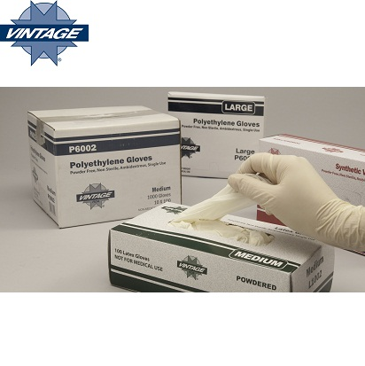
- Goggles
- Wall Air Freshener
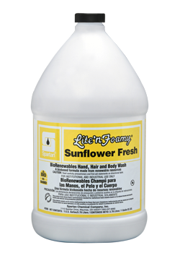
- Disinfectant Cleaner
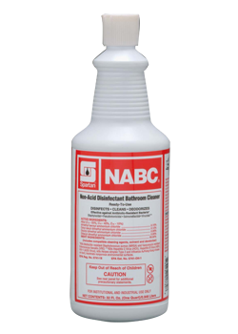
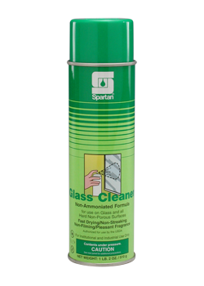
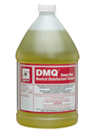
- Glass Cleaner
- Toilet Bowl Cleaner
- Hand Soap
- Paper Towels
- Towel Dispenser
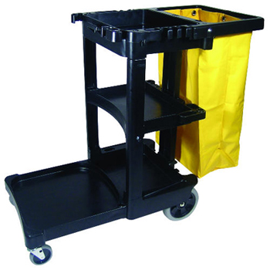
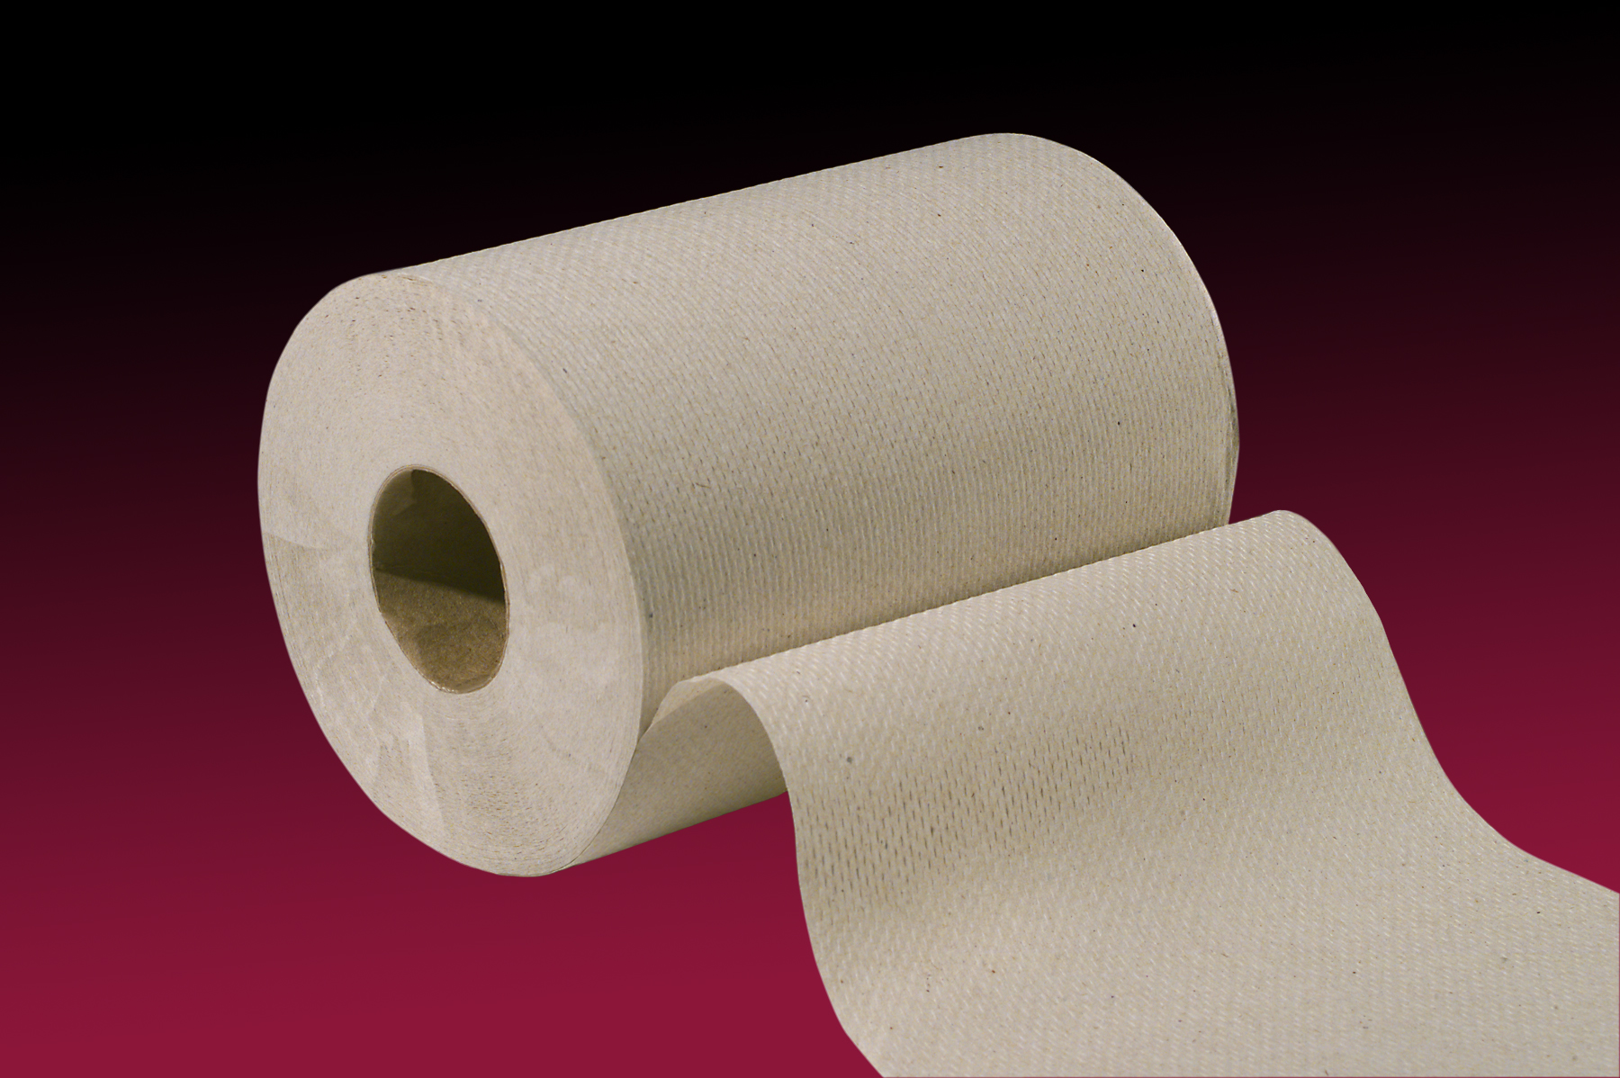
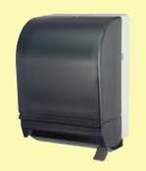
- Toilet Tissue
- Toilet Tissue Dispenser
- Sanitary napkins/tampons
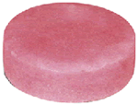
- Urinal Blocks
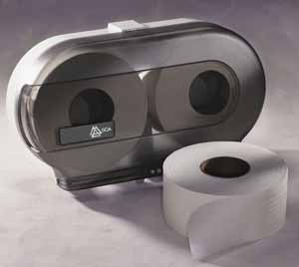
- Janitor Cart W/Bag
